Lab Sheet–01
Title: Lab Environment Setup, Python Libraries Installation

1. Objective

- To install and configure Python for Data Science and Machine Learning.
- To install important Python libraries like NumPy, Pandas, Matplotlib, Seaborn and Scikit-learn.
- To learn how to use Jupyter Notebook and Python IDEs.
- To load, inspect and explore datasets using Python.
- To understand basic data preprocessing techniques.

2. Requirements

- Python 3.11 or above
- Anaconda Distribution or Python Installer
- Jupyter Notebook / JupyterLab / VS Code / PyCharm
- NumPy
- Pandas
- Matplotlib
- Seaborn
- Scikit-learn
- Internet Connection

3. Programs

Program 1: Install Python and Verify Version

Aim:
To check the installed Python version.

Code:

import sys
print(sys.version)

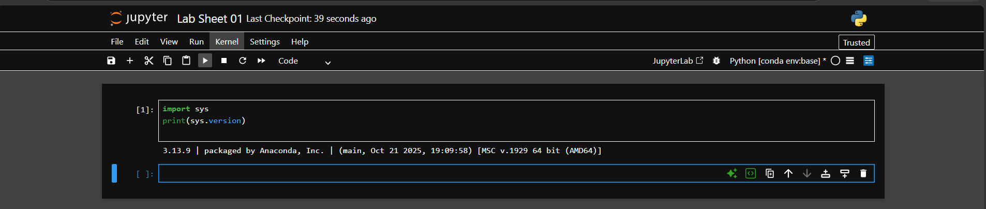

Program 2: Install Jupyter Notebook

Aim:
To install and launch Jupyter Notebook.

Code:

!pip install notebook

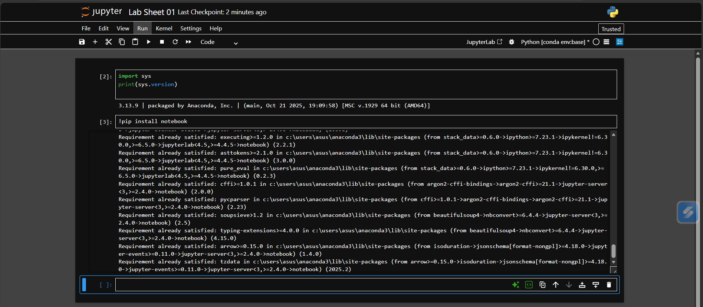

Program 3: Install NumPy

Aim:
To install NumPy and verify its installation.

Code:

!pip install numpy
import numpy as np
print(np.__version__)

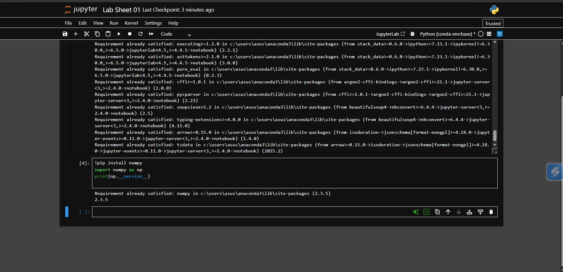

Program 4: Install Pandas

Aim:
To install Pandas and verify its installation.

Code:

!pip install pandas
import pandas as pd
print(pd.__version__)

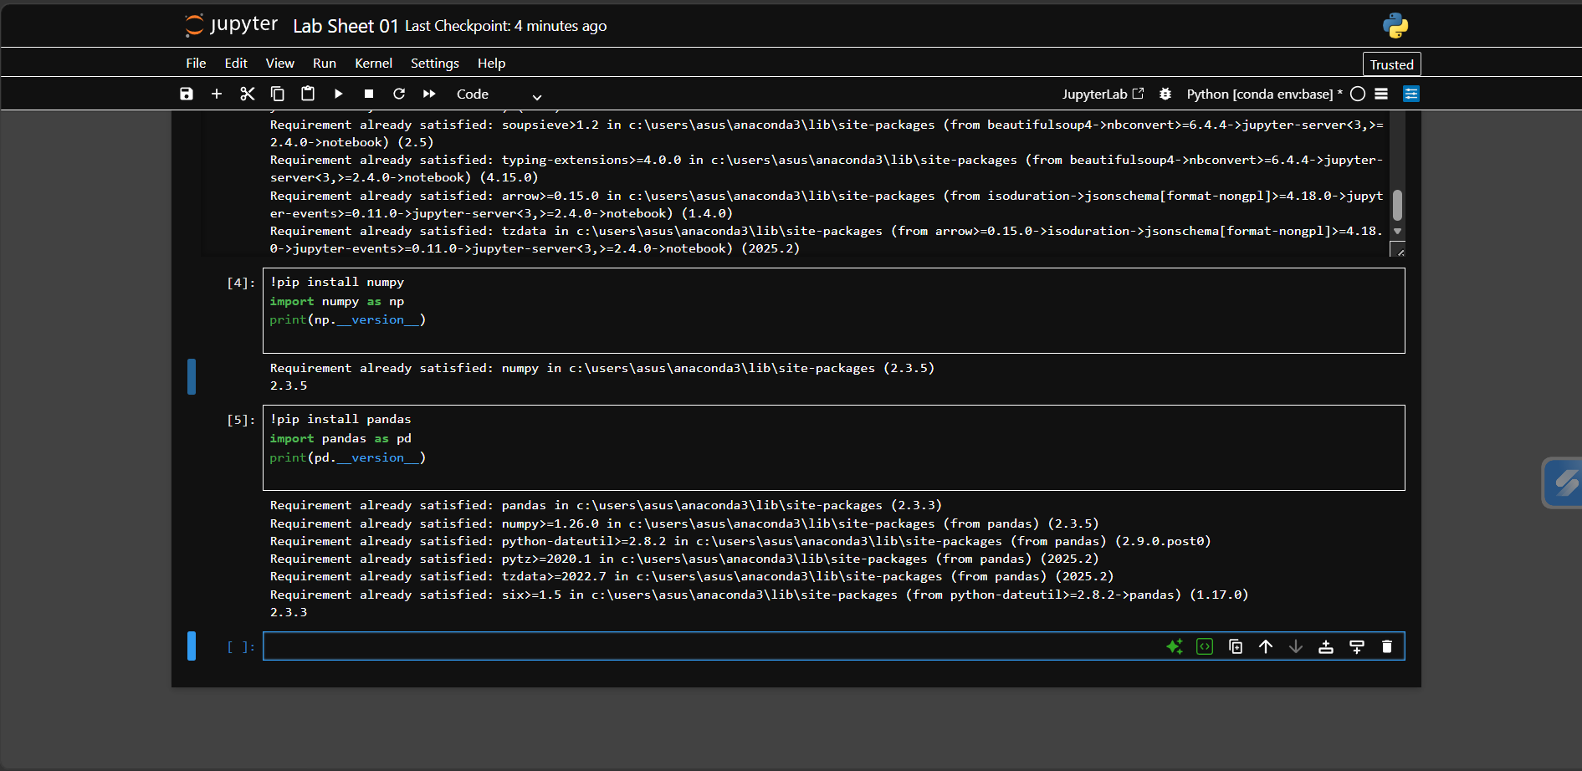

Program 5: Install Matplotlib and Create Line Plot

Aim:
To create a simple line plot using Matplotlib.

Code:

import matplotlib.pyplot as plt

x = [1, 2, 3, 4]
y = [10, 20, 15, 25]

plt.plot(x, y)
plt.show()
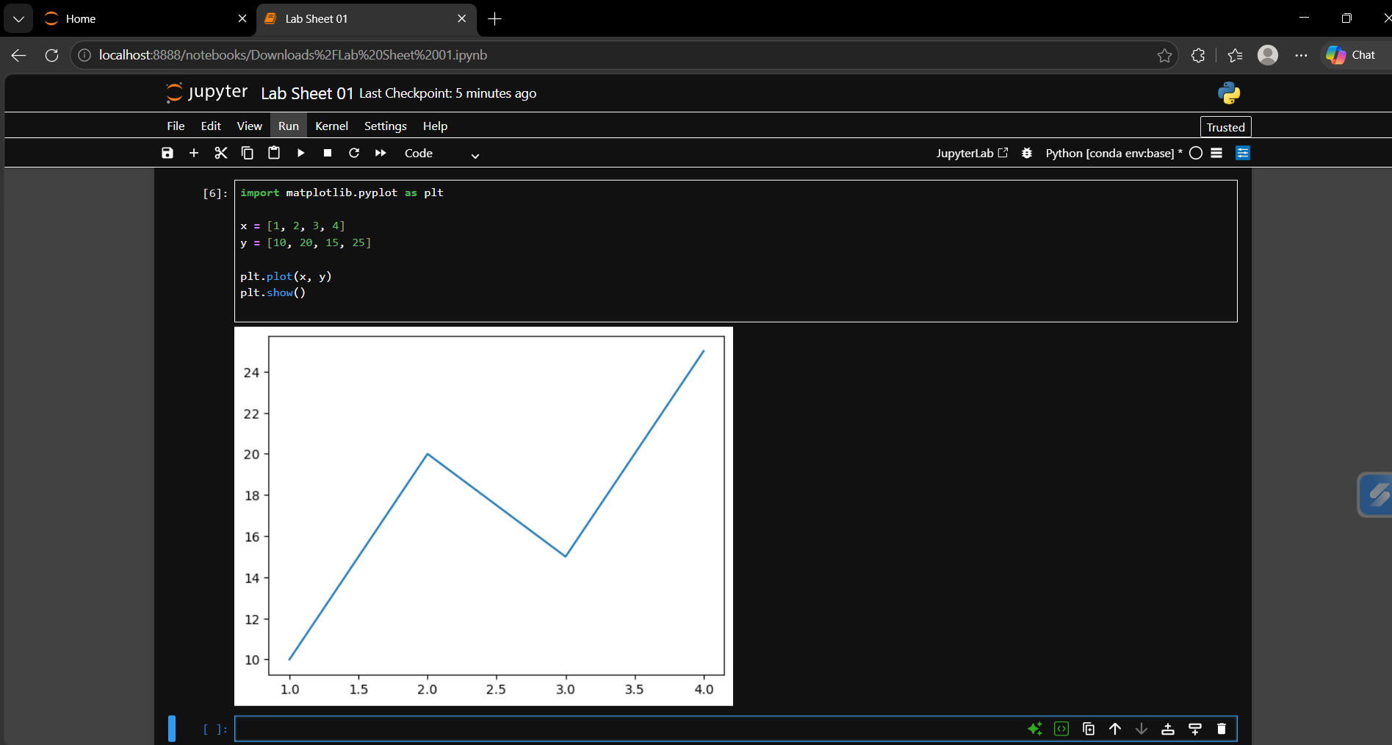

Program 6: Install Seaborn and Create Statistical Plot

Aim:
To create a basic statistical plot using Seaborn.

Code:

import seaborn as sns

data = [10, 20, 15, 25, 30]
sns.histplot(data)

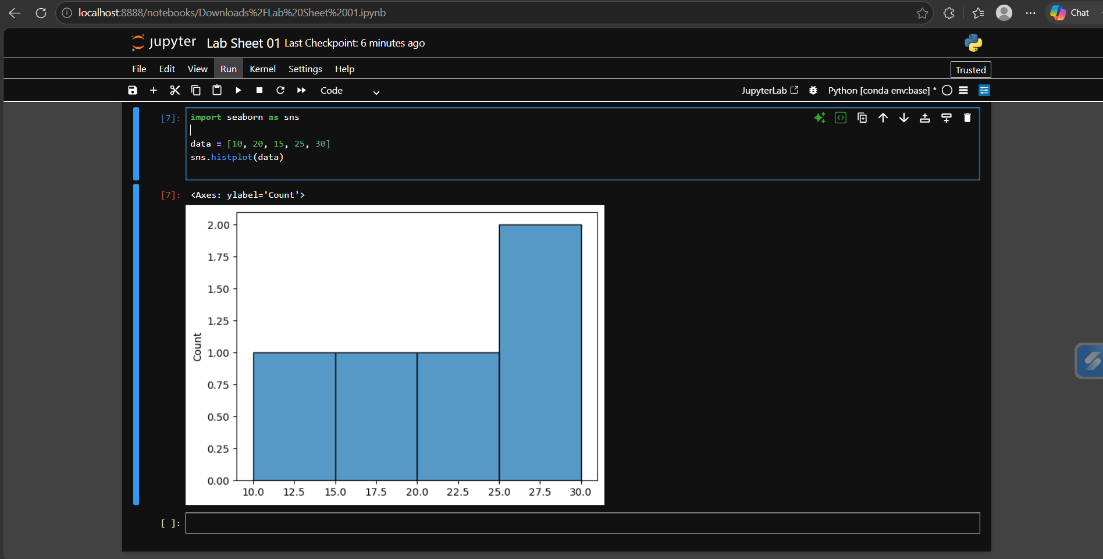

Program 7: Install Scikit-learn

Aim:
To install Scikit-learn and verify its version.

Code:

!pip install scikit-learn
import sklearn
print(sklearn.__version__)

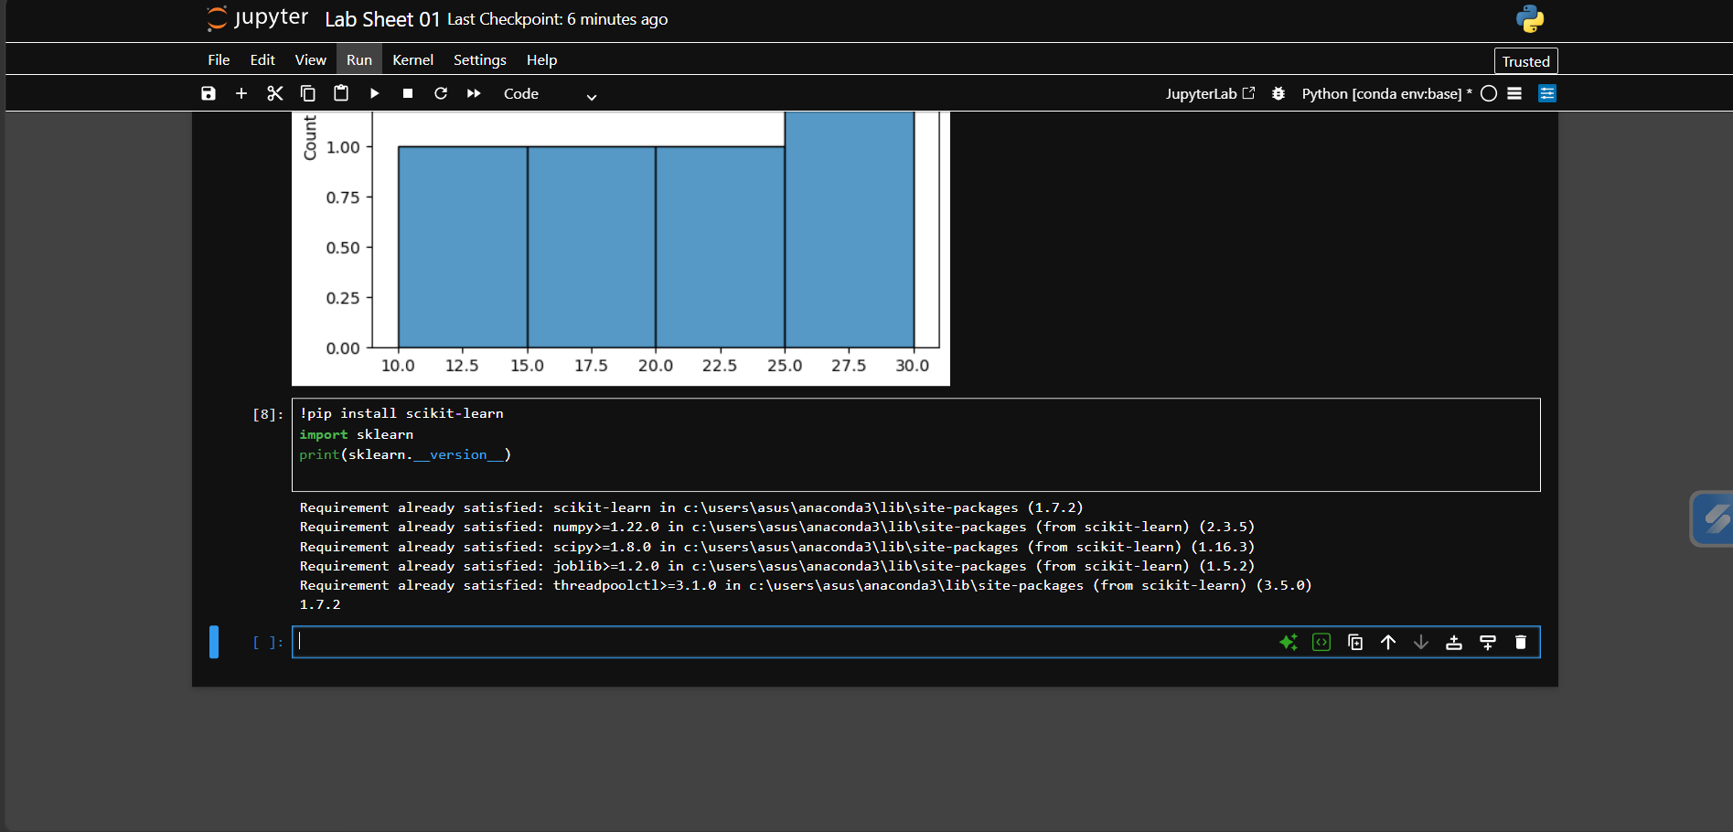

Program 8: First Python Program in Jupyter Notebook

Aim:
To create and execute the first Python program.

Code:

print("Hello World")
print("Welcome to Machine Learning")

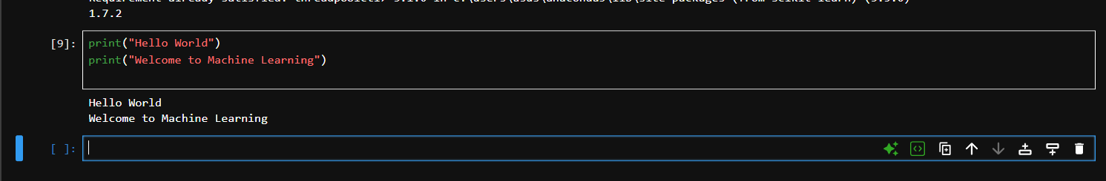
Program 9: Create Python Script in VS Code/PyCharm

Aim:
To create and execute a Python script.

Code:

name = "Dhruv"
print("Hello", name)

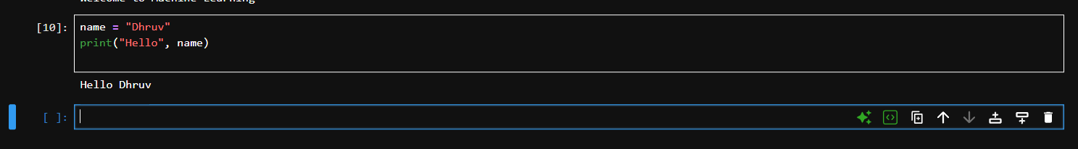

Program 10: Create Virtual Environment

Aim:
To create a virtual environment and install a library.

Code:

!python -m venv myenv

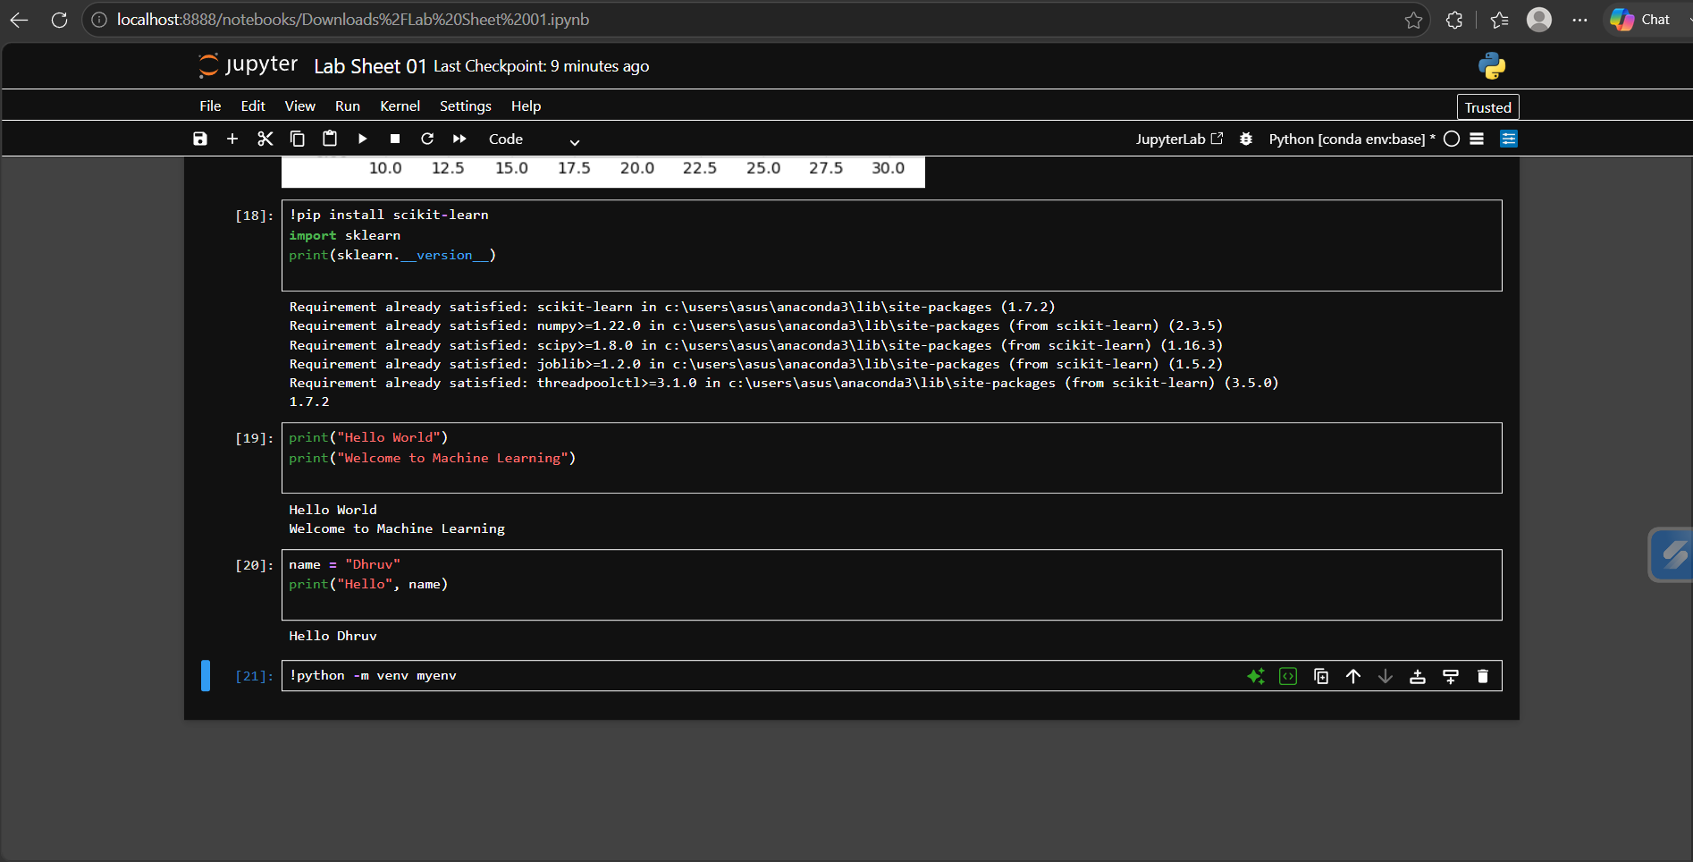

Program 11: Load a CSV Dataset

Aim:
To load a CSV dataset using Pandas.

Code:

import pandas as pd

df = pd.read_csv("data.csv")
print(df)

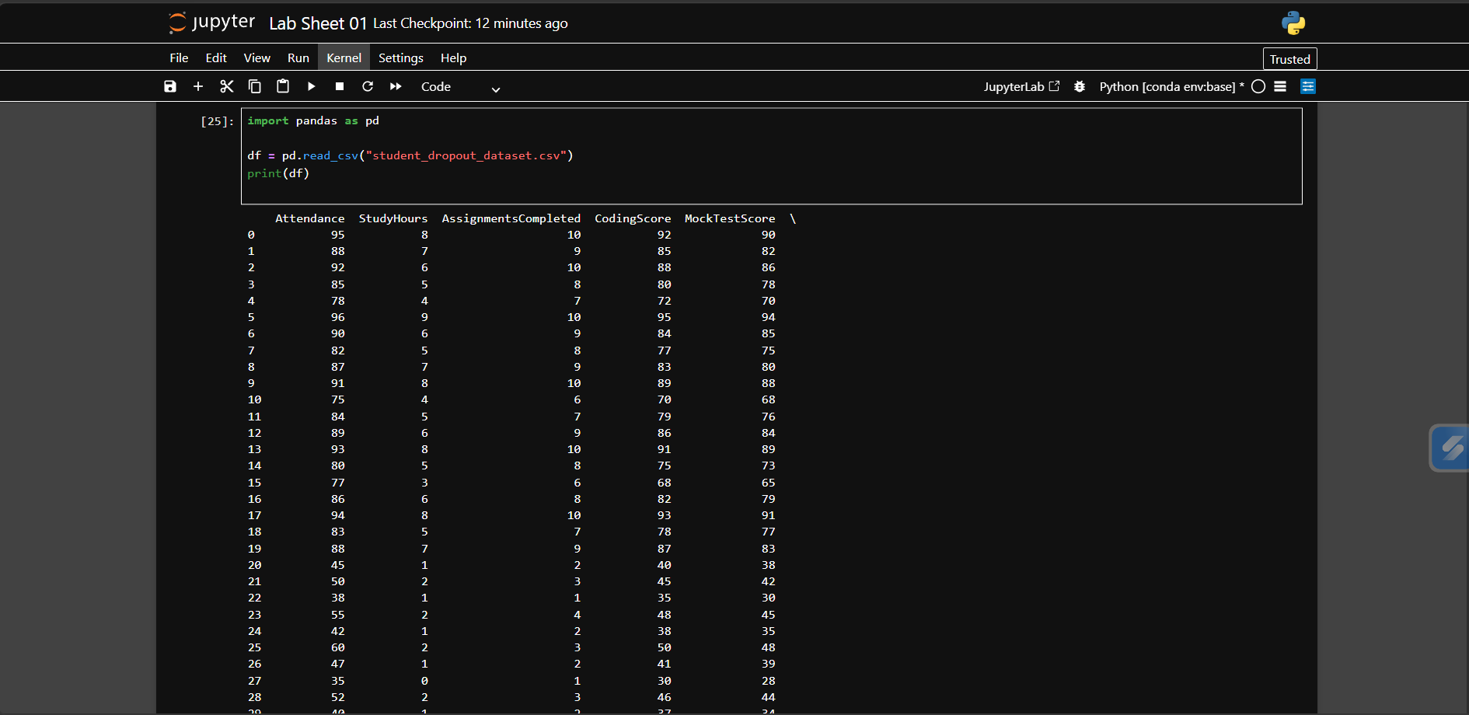

Program 12: Display First Five Records

Aim:
To display the first five records using "head()".

Code:

print(df.head())

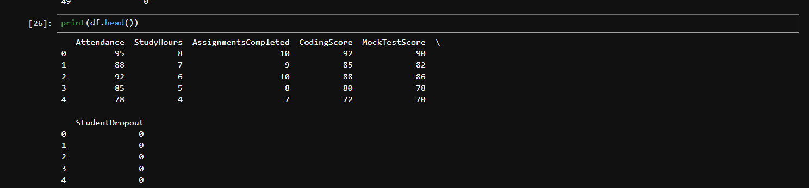

Program 13: Display Last Five Records

Aim:
To display the last five records using "tail()".

Code:

print(df.tail())

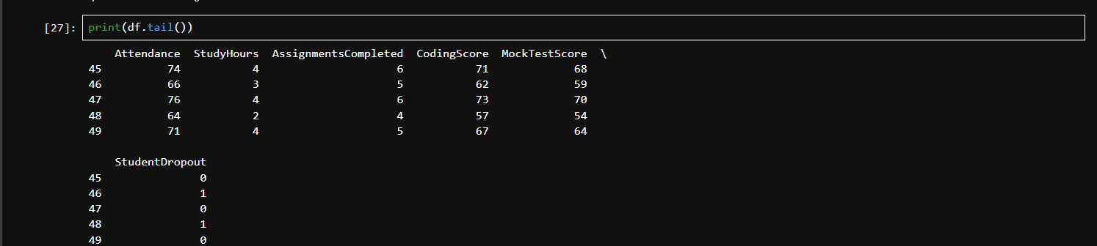

Program 14: Find Rows and Columns

Aim:
To find the total number of rows and columns.

Code:

print(df.shape)

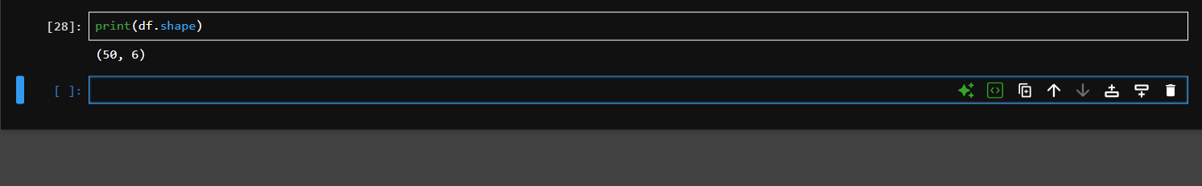

Program 15: Display Column Names

Aim:
To display the names of all columns.

Code:

print(df.columns)

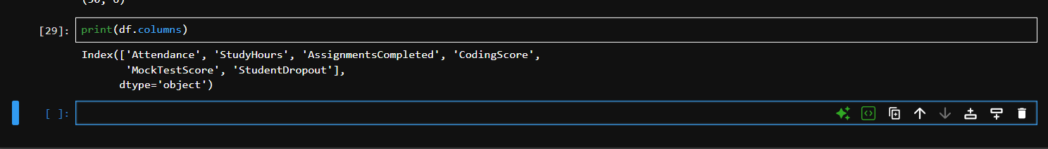

Program 16: Check Data Types

Aim:
To check the data types of all columns.

Code:

print(df.dtypes)

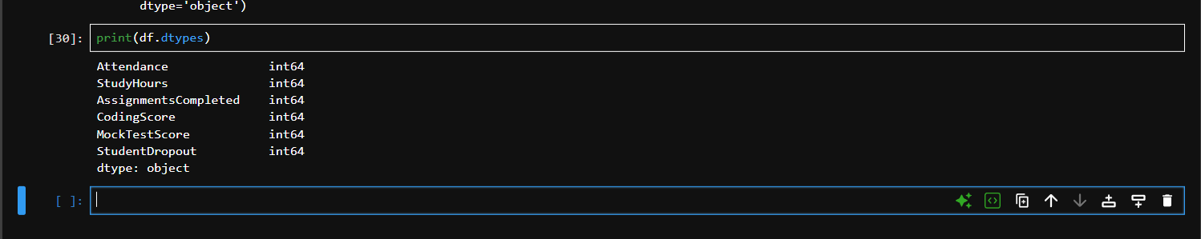

Program 17: Descriptive Statistics

Aim:
To generate descriptive statistics of numerical data.

Code:

print(df.describe())

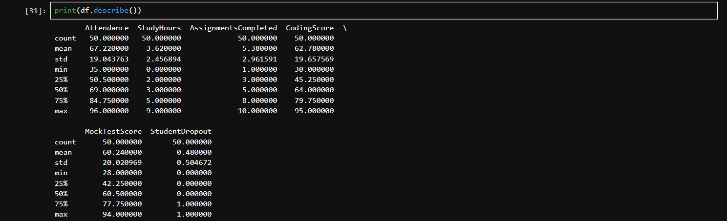

Program 18: Display Dataset Information

Aim:
To display complete information about the dataset.

Code:

df.info()

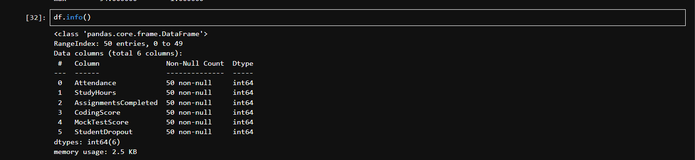

Program 19: Identify Missing Values

Aim:
To identify missing values in the dataset.

Code:

print(df.isnull())

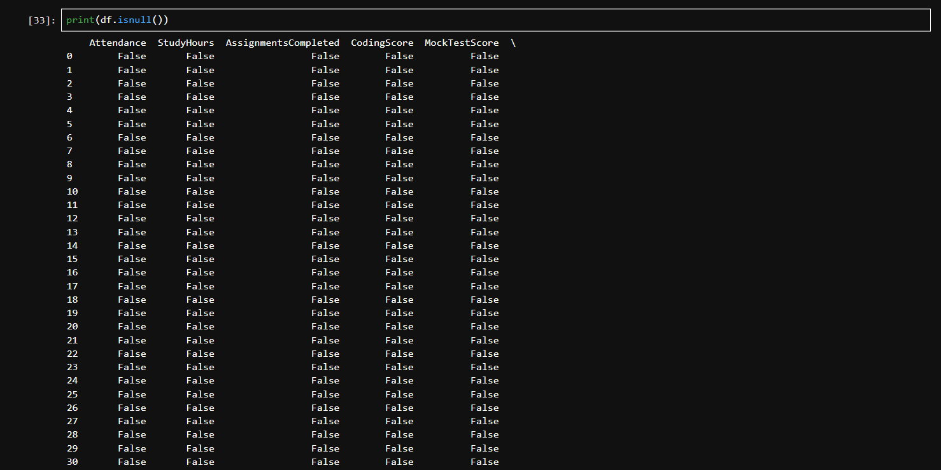

Program 20: Count Missing Values

Aim:
To count missing values in each column.

Code:

print(df.isnull().sum())

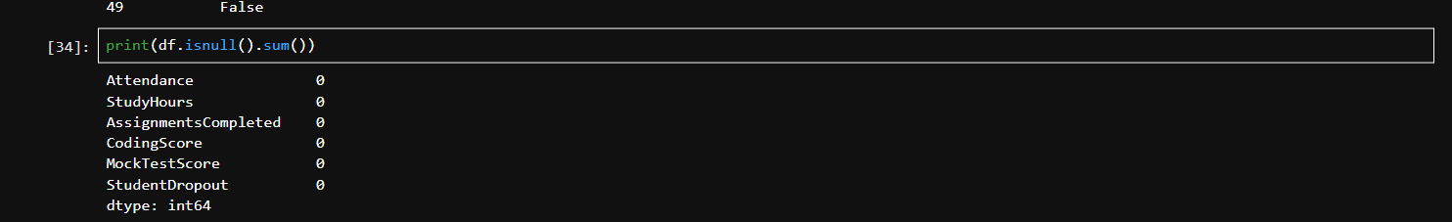

Program 21: Display Unique Values

Aim:
To display unique values of a selected column.

Code:

print(df["Name"].unique())

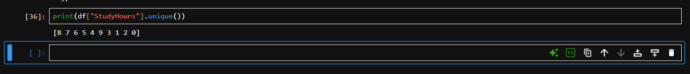

Program 22: Count Frequency of Unique Values

Aim:
To count the frequency of each unique value.

Code:

print(df["Name"].value_counts())

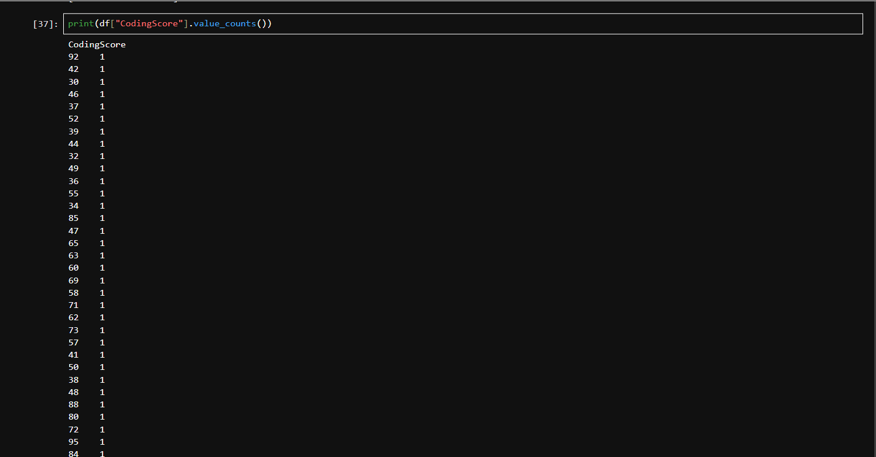

Program 23: Rename Columns

Aim:
To rename one or more columns.

Code:

df = df.rename(columns={"Name": "Student_Name"})
print(df.head())

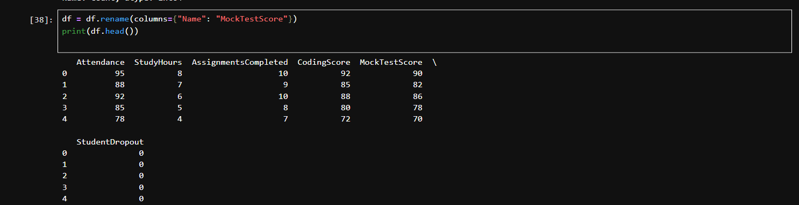

Program 24: Select Rows and Columns Using loc[]

Aim:
To select specific rows and columns using "loc[]".

Code:

print(df.loc[0:2, ["Student_Name"]])

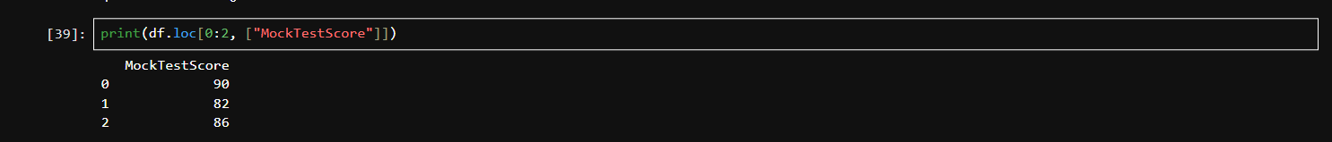

Program 25: Select Rows and Columns Using iloc[]

Aim:
To select rows and columns using "iloc[]".

Code:

print(df.iloc[0:3, 0:2])

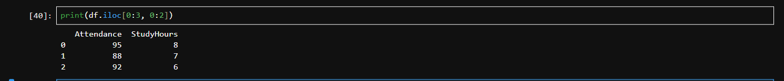

Program 26: Filter Records

Aim:
To filter records based on a condition.

Code:

print(df[df["Age"] > 18])

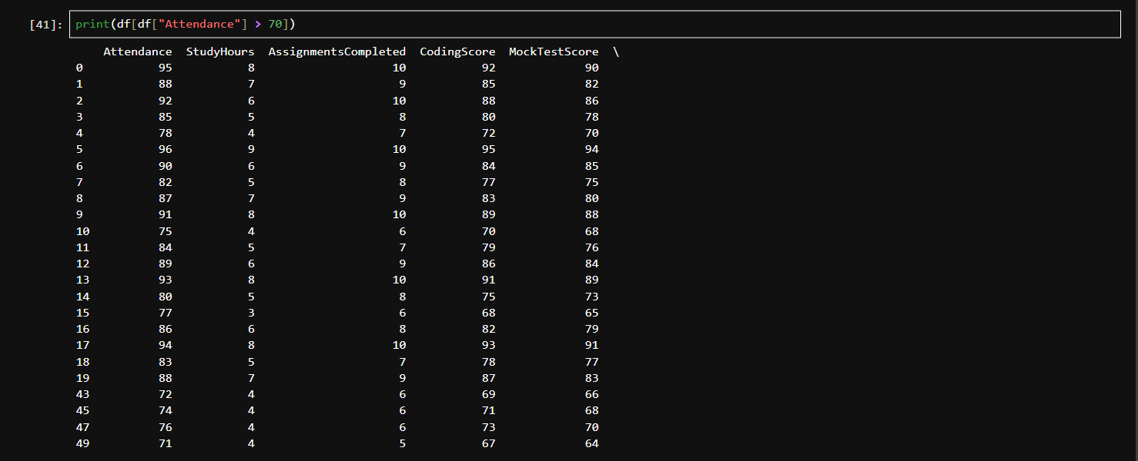
Program 27: Sort Dataset

Aim:
To sort the dataset using a column.

Code:

df = df.sort_values("Age")
print(df)

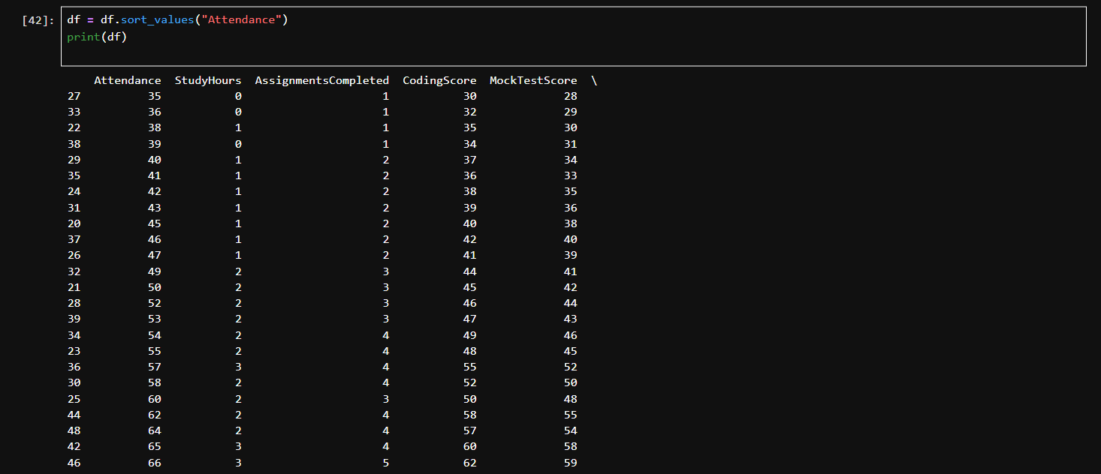

Program 28: Add a New Column

Aim:
To add a new column to the dataset.

Code:

df["Passed"] = True
print(df.head())

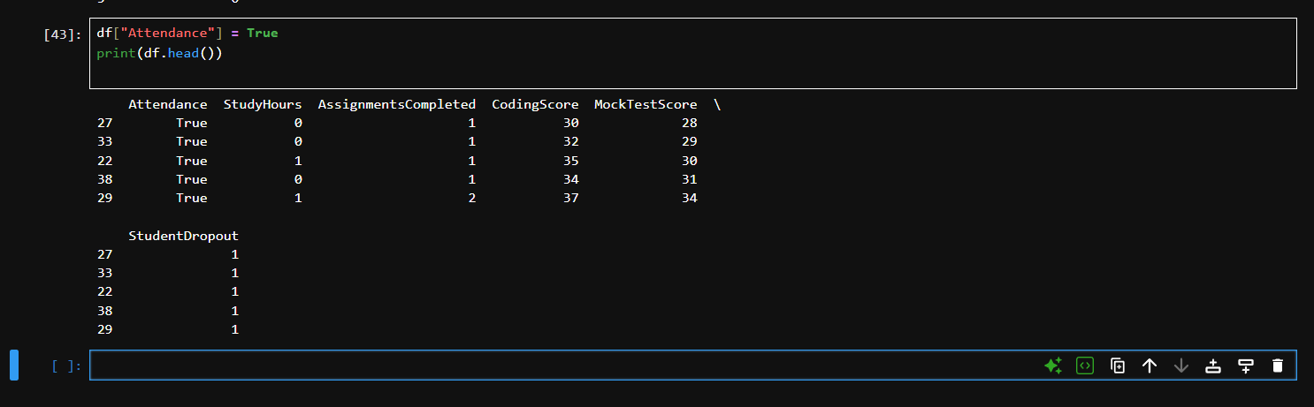

Program 29: Delete a Column

Aim:
To delete an existing column.

Code:

df = df.drop("Passed", axis=1)
print(df.head())

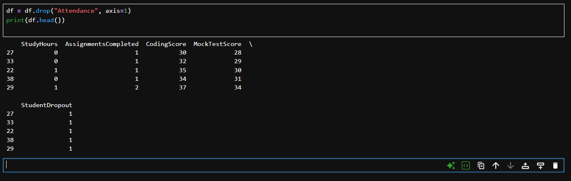

Program 30: Remove Duplicate Records

Aim:
To remove duplicate records from the dataset.

Code:

df = df.drop_duplicates()
print(df)

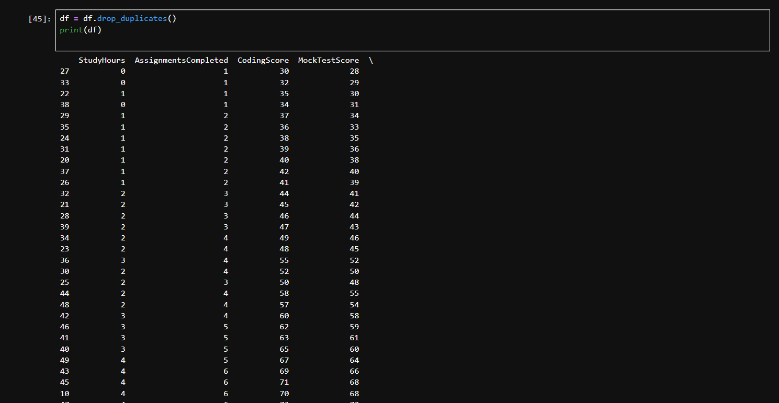

Program 31: Save Modified Dataset

Aim:
To save the modified dataset as a new CSV file.

Code:

df.to_csv("new_data.csv", index=False)
print("Dataset saved successfully")

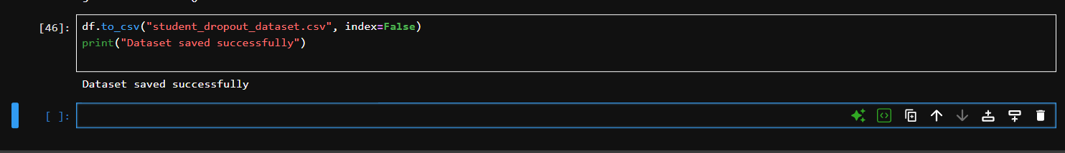

Program 32: Load Dataset from Scikit-learn

Aim:
To load a dataset directly from Scikit-learn.

Code:

from sklearn.datasets import load_iris

iris = load_iris()
print(iris.data[:5])

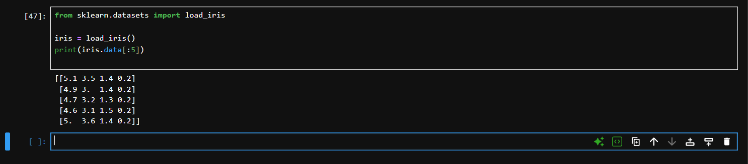

Program 33: Create Histogram

Aim:
To create a histogram for a numerical feature.

Code:

import matplotlib.pyplot as plt

plt.hist(iris.data[:, 0])
plt.show()

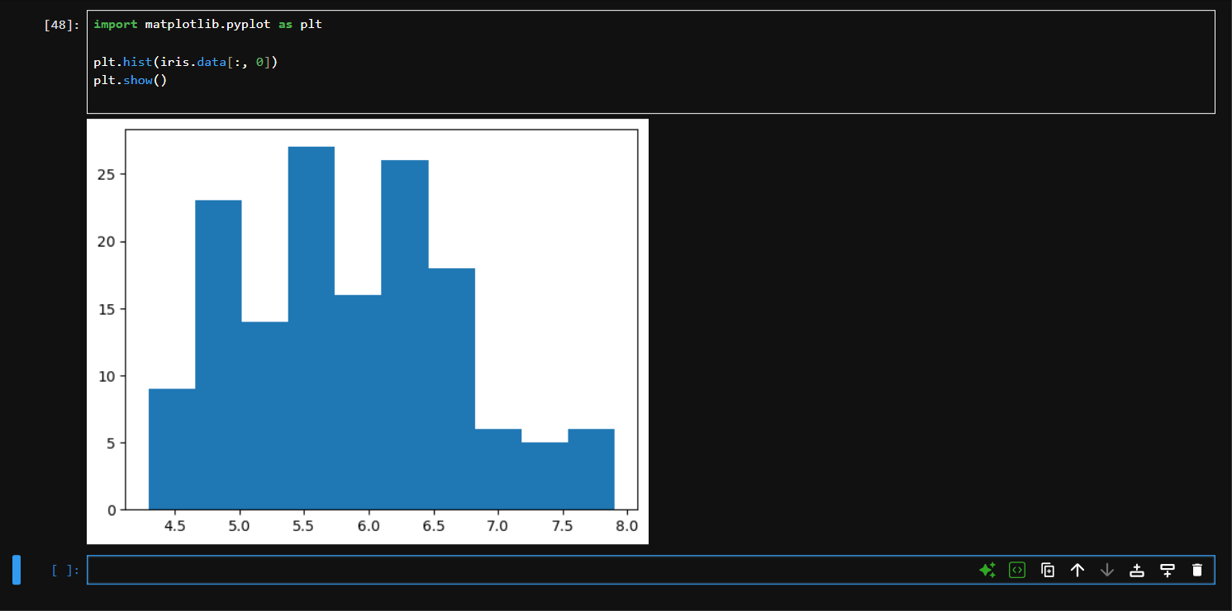

Program 34: Create Scatter Plot

Aim:
To visualize the relationship between two variables.

Code:

plt.scatter(iris.data[:, 0], iris.data[:, 1])
plt.xlabel("Feature 1")
plt.ylabel("Feature 2")
plt.show()

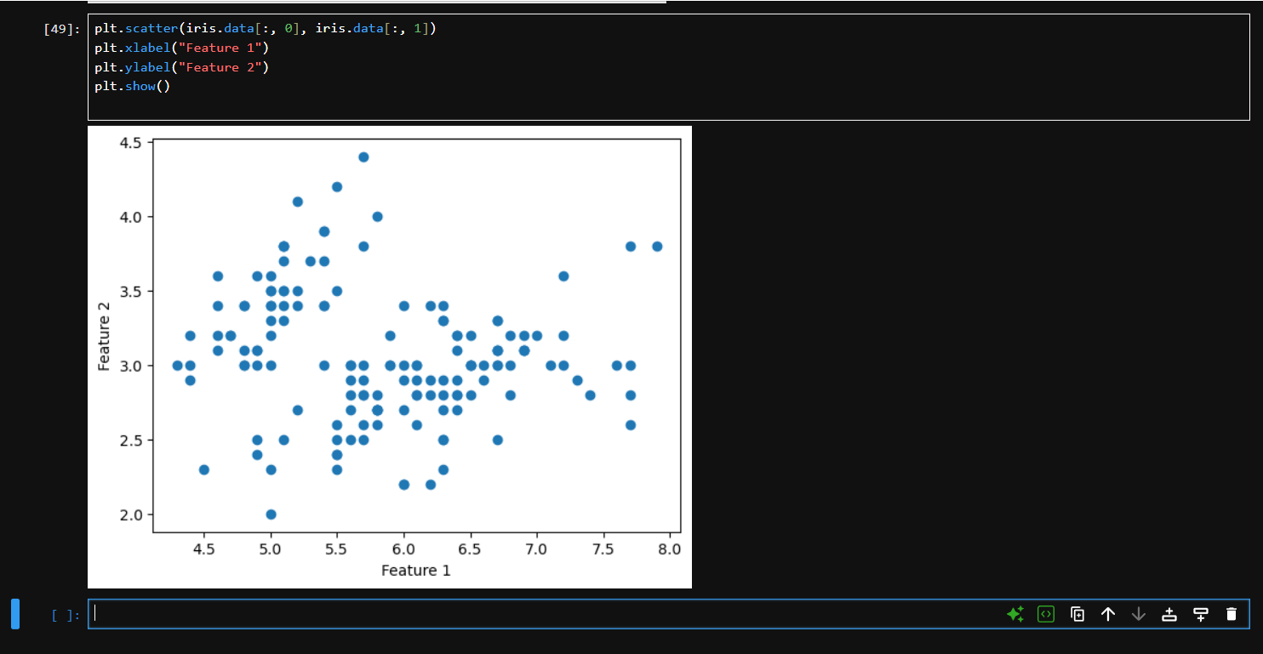

Program 35: Correlation Matrix and Heatmap

Aim:
To generate a correlation matrix and display it using a heatmap.

Code:

import seaborn as sns
import pandas as pd
import matplotlib.pyplot as plt

corr = pd.DataFrame(iris.data).corr()
sns.heatmap(corr, annot=True)
plt.show()

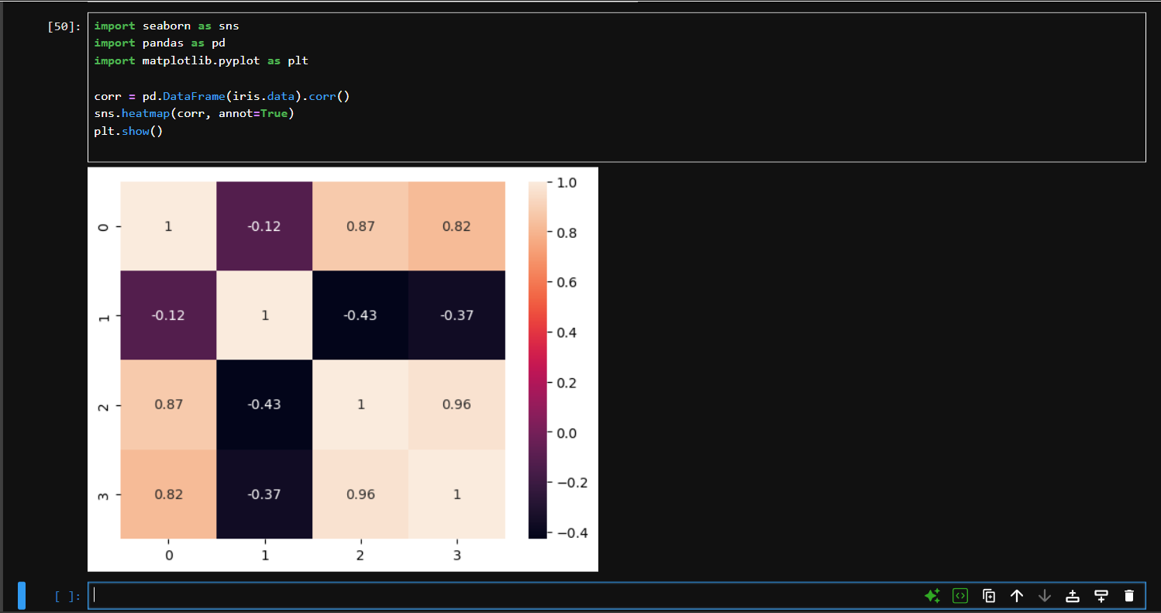

http://localhost:8888/lab/tree/Downloads/Lab%20Sheet%2001.ipynb

4. Conclusion

Thus, the Python environment and required libraries were successfully set up.
I learned how to load, inspect, process and visualize datasets using Python.
I also practiced basic Pandas, Matplotlib, Seaborn and Scikit-learn operations.

